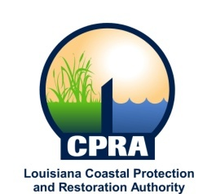

2012 Public Meetings

Garrett Graves, Chairman of the Coastal Protection and Restoration Authority, and Executive Assistant to Governor Bobby Jindal for Coastal Activities has announced the public meetings schedule for the Coastal Protection and Restoration Authority and the Governor’s Advisory Commission on Coastal Protection, Restoration and Conservation. Details on each meeting will be sent out at a later date. The dates and locations of these meetings are subject to change

CPRA
January 18, 2012
Baton Rouge, LA

February 15, 2012
New Orleans, LA

March 21, 2012
Baton Rouge, LA

April 25, 2012
Baton Rouge, LA

May 16, 2012
Baton Rouge, LA

June 20, 2012
Baton Rouge, LA

July 18, 2012
Larose, LA

August 22, 2012
Baton Rouge, LA

September 19, 2012
Belle Chasse, LA

October 17, 2012
Baton Rouge, LA

November 28, 2012
Baton Rouge, LA

December 18, 2012
Baton Rouge, LA

Governor’s Advisory Commission
January 27, 2012
New Orleans, LA

March 14, 2012
Baton Rouge, LA

April 4, 2012
Baton Rouge, LA

June 6, 2012
Baton Rouge, LA

August 1, 2012
Braithwaite, LA

October 3, 2012
New Orleans, LA

December 5, 2012
Baton Rouge, LA

